# EXPERIMENT 6

**Aim:**

Interfacing of digital sensor HC-SR04.

# Components Required:

1. HC-SR04 Ultrasonic Sensor
2. Arduino UNO
3. Bread Board
4. Jump wires
5. USB cable

# Theory:

The HC-SR04 Ultrasonic Sensor operates based on the principle of ultrasonic waves. Ultrasonic waves are sound waves with frequencies higher than the upper audible limit of human hearing, which is approximately 20 kHz. The HC-SR04 sensor emits ultrasonic pulses and measures the time it takes for these pulses to bounce back after hitting an object. This time measurement allows the sensor to calculate the distance to the object.

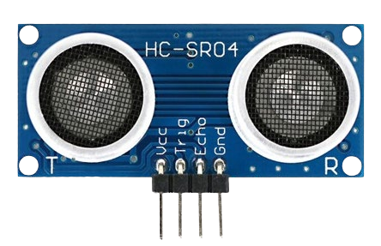The sensor consists of two main components: a transmitter and a receiver. The transmitter emits short ultrasonic pulses, while the receiver detects the echoes of these pulses after they bounce off nearby objects. The time delay between sending the pulse and receiving its echo is directly proportional to the distance between the sensor and the object.

The HC-SR04 sensor has four pins:

1. VCC: Power supply pin (5V)
2. Trig (Trigger): Input pin for triggering the sensor
3. Echo: Output pin for receiving the echo signal
4. GND: Ground pin

# Sketch Code:

#define echoPin 2

#define trigPin 3 long duration; int distance;

void setup(){ pinMode(trigPin, OUTPUT); pinMode(echoPin, INPUT); Serial.begin(9600);

Serial.println(“Ultrasonic Sensor HC-SR04 Test”);

}

void loop(){ digitalWrite(trigPin, LOW); delayMicroseconds(20000); digitalWrite(trigPin, HIGH); delayMicroseconds(10000); digitalWrite(trigPin, LOW);

duration = pulseIn(echoPin, HIGH); distance = duration * 0.034 / 2; Serial.print(“Distance: ”); Serial.print(distance); Serial.println(“ cm”);

delay(1000);

}

# Result:

Upon successful execution of the code and interfacing of the HC-SR04 sensor with the Arduino Uno, the serial monitor will display the distance measurements in centimeters. The distance readings will vary as per the distance between the sensor and the object.

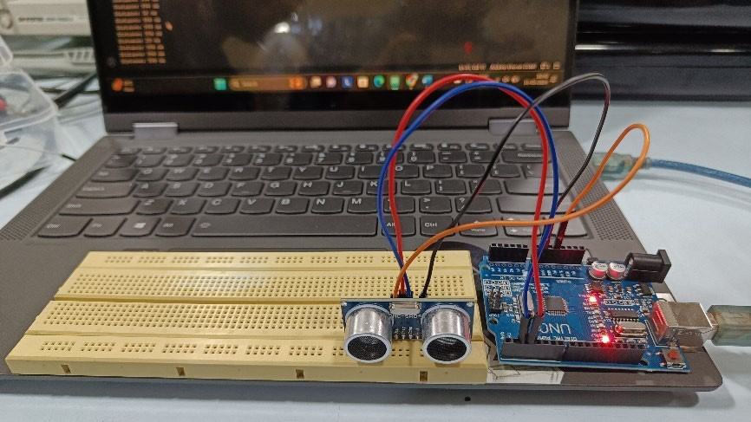

# Conclusion:

In this lab, we have successfully interfaced the HC-SR04 digital sensor with the Arduino Uno microcontroller. We have understood the working principle of the HC-SR04 sensor and utilized it for distance measurement applications.

Krushna kanta sahoo

22052467

# EXPERIMENT 7

**Aim:**

Interfacing of analog sensor LM35.

# Components Required:

1. LM35 Temperature sensor
2. Arduino Uno
3. Breadboard
4. Jump wires
5. USB cable

# Theory:

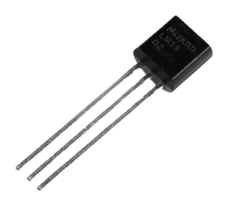The LM35 is a precision integrated-circuit temperature sensor that provides an analog voltage output directly proportional to the temperature in Celsius. It has a linear scale factor of 10 mV/°C, which means that every 1°C change in temperature results in a 10 mV change in output voltage.

The LM35 does not require any external calibration or trimming and can measure temperatures ranging from -55°C to +150°C. It operates from a 4V to 20V supply voltage and typically draws only 60 µA of current.

The LM35 sensor has three pins:

1. VCC: Power supply pin (Typically connected to 5V)
2. OUT: Output pin for the temperature voltage signal
3. GND: Ground pin

# Sketch Code:

const int lm35_pin = A1;

void setup(){ Serial.begin(9600);

}

void loop(){

int temp_adc_val; float temp_val;

temp_adc_val = analogRead(lm35_pin); temp_val = (temp_adc_val * 4.88); temp_val = (temp_val / 10); Serial.print(“Temperature = ”); Serial.print(temp_val);

Serial.print(“ Degree Celsius\n”); delay(1000);

}

# Result:

Upon successful execution of the code and interfacing of the LM35 sensor with the Arduino Uno, the temperature readings in Celsius being displayed on the serial monitor.

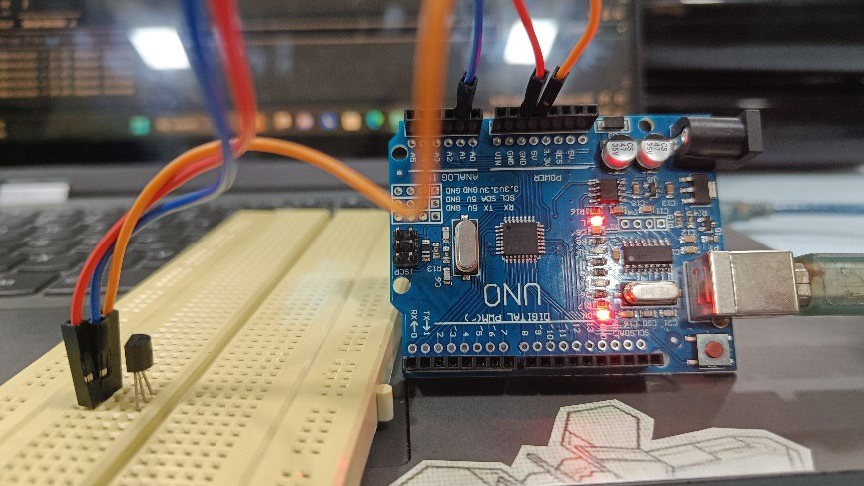

# Conclusion:

The LM35 Temperature Sensor successfully interfaces with the Arduino board, and accurate temperature readings can be obtained. The experiment demonstrates the principle of temperature sensing using the LM35 sensor and the analog-to-digital conversion capability of the Arduino. It can be further extended to incorporate additional features such as temperature control systems, data logging, and display units.

Vikash Kumar Shaw

22052694